
TOWN OF TRUCKEE
COMMUNITY DEVELOPMENT DEPARTMENT
BUILDING AND SAFETY DIVISION

Bedroom Information Guide

This document is intended to provide clarification on the building permit process, including key definitions, regulations and requirements associated with permitting a space as a bedroom within a dwelling.

BEDROOM DEFINITION*:

STR Ordinance - 5.02.020:
“Bedroom” means an enclosed habitable room planned and intended for sleeping, separated from other rooms by a door, and accessible without crossing another bedroom, closet space, or bathroom. A bed- room will have a built-in closet, emergency escape and rescue opening(s), and a minimum floor area of seventy (70) square feet, exclusive of a closet. Additionally, the construction of the room shall have been authorized by a building permit, and the room shall comply with all codes in effect at the time of construction or conversion into a bedroom.

Development Code Chapter 18.220:
Bedroom. An enclosed habitable room planned and intended for sleeping, separated from other rooms by a door and accessible without crossing another bedroom, closet space, or bathroom. A bedroom will have a closet, emergency escape and rescue opening(s), and a minimum floor area of 70 square feet, exclusive of a closet. Additionally, it shall meet the requirements or be in accordance with the current codes adopted by the Town as listed in Title 15 of the Municipal Code.

PERMIT PROCESS:
- Permit History: we suggest doing a permit history search/request to determine what the Town has on file for your property. Please visit the following website for more information:
- https://www.townoftruckee.gov/building-and-safety/building-public-records
If there are plans on file for your residence, we will accept partial floor plans (showing only area where work is proposed) to be submitted, but if we don’t, the full house plans must be submitted.
- Application/Submittal: start an application with the Building Division by sending a permit request form and a complete submittal for processing. The plan review time and required documentation will differ based on the scope of work.
- Review Process: once received, the application will be processed, routed for review and staff reach out with any questions and once permit is ready for issuance.
- Issuance/Inspections: once permit is issued, staff will relay steps on how to request inspections.
The permit will be completed when all applicable inspection are resulted as “passed”.

SUBMITTAL REQUIREMENTS:
- At a minimum, the applicant shall submit:
  - Permit Request Form
  - Existing and proposed plans (minimum size 11x17”), which are drawn to scale, clear, legible and mirror the example provided at the end of this document (see page 6 and 7).
    - Please label each proposed room and provide dimensions and ceiling height.

The requirements above apply to projects converting an existing permitted living space into a bedroom.
- If your project scope consists of converting a garage or crawl space, or proposing any structural modification, i.e. adding a window, a full submittal will be required (link to document).
- If applicable, the following should be included with your submittal: electrical plans, structural plans, energy calculations, structural calculations, etc.

GENERAL CODE REQUIREMENTS:
Please carefully read all of the requirements below and make sure they are addressed on the plans.

CLOSET DEFINITION - A framed-in or permanently built-in enclosed area for storage with space for hanging clothes and with a minimum volume of 48 cubic feet. Includes a separate room for storage but does not include removable storage units or furniture such as wardrobes or armoires.

CRC R303.1 / R303.10 Light, Ventilation and Heating:
  - A natural light source with an area of not less than 8% of the floor area must be provided. Examples: windows, skylights, doors, etc. Exception: artificial light of 6 foot-candles at 30” above floor.
  - Natural ventilation through openings to the outdoor air with an area of not less than 4% of the floor area is required. Exception: whole-house mechanical ventilation system.
  - It shall be provided with heating capable of maintaining a room temperature of 68 degrees F at a point 3 feet above the floor and 2 feet from exterior walls.
CRC R304.1 / R304.2 – Minimum area and dimensions:
  - The room shall have a minimum of 70 SF of floor area and not less than 7 feet in any horizontal dimension.
CRC R305.1 – Minimum height:
  - The room shall have a ceiling height not less than 7 feet.
- In rooms with sloped ceilings, the required floor area of the room shall have a ceiling height of not less than 5 feet, with at least 50% not less than 7 feet.
CRC R310 Emergency Escape and Rescue Openings:
  - The room shall have an emergency escape and rescue opening, which can be a door or a window opening to a public way. It must be operable from the inside and provide a net clear opening at least 24" high, 20" wide and 5.7 SF area (5.0 SF for grade floor openings) – see diagram 1 below.
  - Where a window is provided as the emergency escape and rescue opening it shall have the bottom of the clear opening not greater than 44 inches above the floor.
CRC R314 / R315 Smoke Alarms and Carbon Monoxide Alarms:
  - A smoke detector is required to be installed in each bedroom and outside of each bedroom in the immediate vicinity.
  - A carbon monoxide alarm is required outside of each bedroom in the immediate vicinity, and in bedrooms (or attached bathroom) that contain a fuel-fired appliance or fireplace.

Additional requirements:
  - IPMC 404.4.2 Access from bedrooms: Bedrooms shall not constitute the only means of access to other bedrooms or habitable spaces and shall not serve as the only means of egress from other habitable spaces. Exception: Units that contain fewer than two bedrooms.

  - IPMC 404.4.3 – Water closet accessibility: Every bedroom shall have access to not less than one water closet and one lavatory without passing through another bedroom. Every bedroom in a dwelling unit shall have access to not less than one water closet and lavatory located in the same story as the bedroom or an adjacent story.
  - IPMC 404.4.4 – Prohibited occupancy: Kitchens and non-habitable spaces shall not be used for sleeping purposes.
  - Bedrooms shall not have any openings directly to a garage. (CRC R302.5.1)
  - The emergency escape and rescue opening(s) will be in addition to the main bedroom egress (door).
  - At least one wall switch-controlled lighting outlet is required. (CEC 210.70(A)(1))
  - Receptacles shall be installed such that no point measured horizontally along the floor line of any wall space is more than 6 feet from a receptacle outlet. Walls longer than 2 feet shall have a receptacle. (CEC 210.52(A))
  - All lighting shall be high-efficacy. (CEnC 150.0(k)1(A))
  - All new dwelling receptacle outlets that are 125 volt, 15/20 ampere need to be listed as tamper- resistant receptacles (CEC 406.12) and shall be protected by listed combination type arc-fault receptacles (CEC 210.12).
  - For all building alterations or improvements to single-family residences originally built and available for occupancy on or before January 1, 1994, the permit applicant shall replace all existing noncompliant plumbing fixtures with water-conserving plumbing fixtures (applies at the existing residence) (Senate Bill 407) (link to document).
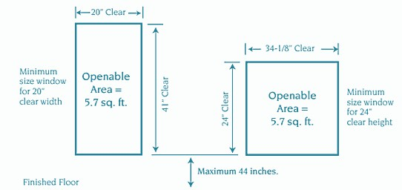
Diagram 1
Formula to calculate openable area: Height x Width (in inches) ÷ 144 = sq. ft. Example: 1⁸3⁵ window – 20”x41” ÷ 144 = 5.7 sq. ft. of openable area.

BLANK SAMPLE SHEET IS PROVIDED AT THE END OF THIS PACKET. FLOOR PLAN EXAMPLE IS PROVIDED AT THE END OF THIS PACKET.

2019 CA RESIDENTIAL CODE
2019 CA BUILDING CODE
2019 CA GREEN BUILDING STANDARDS CODE
2019 CA ELECTRICAL CODE
2019 CA MECHANICAL CODE
2019 CA PLUMBING CODE
2019 CA FIRE CODE
2019 CA BUILDING ENERGY EFFICIENCY STANDARDS TITLE 15 MUNICIPAL CODE





2019 CA RESIDENTIAL CODE
2019 CA BUILDING CODE
2019 CA GREEN BUILDING STANDARDS CODE
2019 CA ELECTRICAL CODE
2019 CA MECHANICAL CODE
2019 CA PLUMBING CODE
2019 CA FIRE CODE
2019 CA BUILDING ENERGY EFFICIENCY STANDARDS TITLE 15 MUNICIPAL CODE
CONVERT EXISTING REC ROMM INTO BEDROOM #4. NO STRUCTURAL WORK IS PROPOSED.


(E) GARAGE

(E) MUDROOM
6'-8" CEILING

(E) REC ROOM
7'-0" CEILING
(E) BATH
6'-8" CEILING

(E) BEDROOM 2
7'-0" CEILING

(E) CLOSET

(E) BEDROOM 3
7'-0" CEILING

(E) CLOSET

(E) DECK

(E) MUDROOM
6'-8" CEILING

(N) CLOSET

(N) 4068
(E) BATH
6'-8" CEILING

(E) BEDROOM 2
7'-0" CEILING

(E) CLOSET

(E) CLOSET

(E) DECK

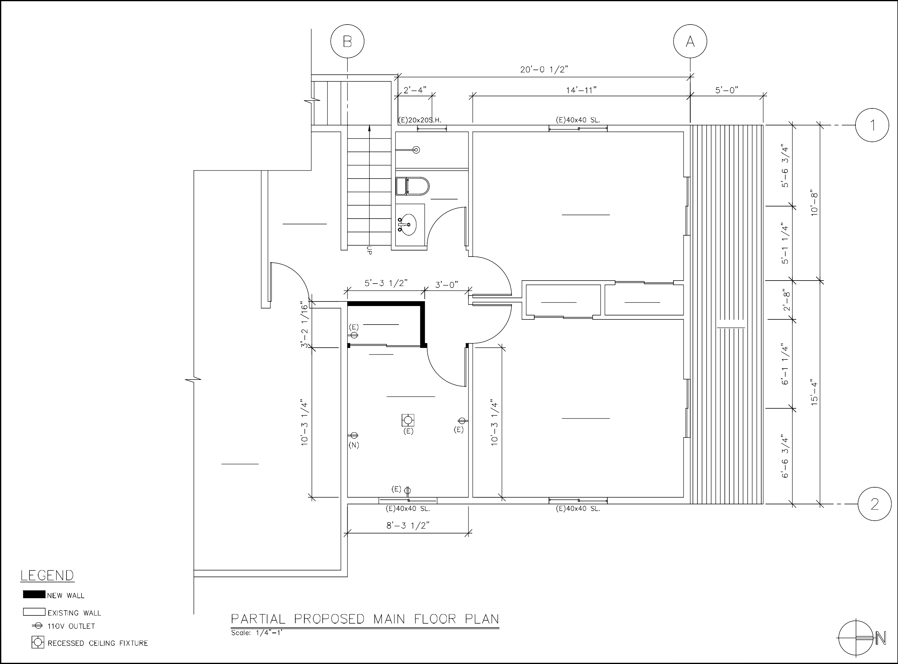
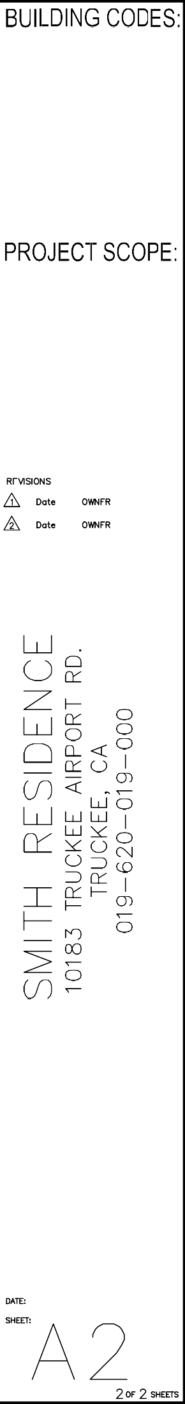
2019 CA RESIDENTIAL CODE
2019 CA BUILDING CODE
2019 CA GREEN BUILDING STANDARDS CODE
2019 CA ELECTRICAL CODE
2019 CA MECHANICAL CODE
2019 CA PLUMBING CODE
2019 CA FIRE CODE
2019 CA BUILDING ENERGY EFFICIENCY STANDARDS TITLE 15 MUNICIPAL CODE
CONVERT EXISTING REC ROOM INTO BEDROOM #4. NO STRUCTURAL WORK IS PROPOSED.

(E) GARAGE
(N) BEDROOM 4
7'-0" CEILING

(E) BEDROOM 3
7'-0" CEILING

